Instruction of FSDAF Program（Python Code）
Yue Sun (sunyuemy@gmail.com), Xiaolin Zhu (zhuxiaolin55@gmail.com)
Department of Land Surveying and Geo-Informatics
The Hong Kong Polytechnic University
Reference
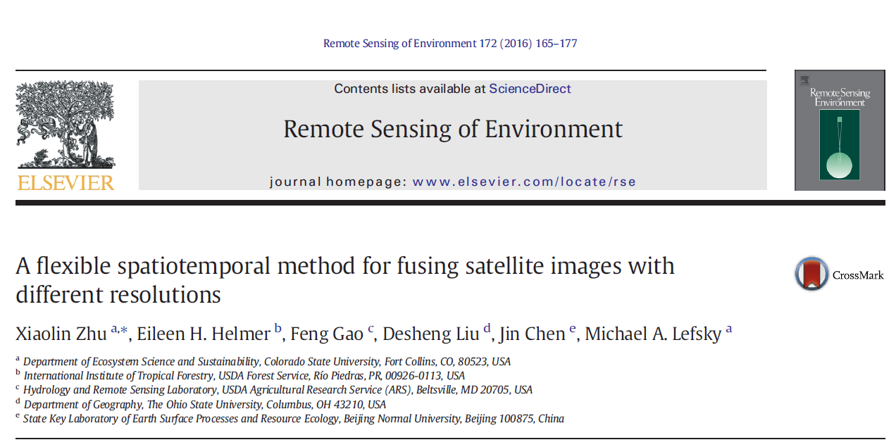
Download link:
https://www.sciencedirect.com/science/article/pii/S0034425715302042?casa_token=aa44zgANFZQAAAAA:NOTT6PyW8VFOh3CLWHW3s_F5CXi0yPHOE1KSjN3rppzspzNSspyFCl3eUSLDEyiY0Bd0sNlFVw
Input data preparation
1) 1 Landsat image;
2) 1 MODIS images at the same time as Landsat image;
3) one MODIS image at the prediction time;
4)* classification map of the Landsat image if using “FSDAF_preclassification.pro” code

Note: size of Landsat image should be k*scale (e.g., scale=480/30, 480 is resampled MODIS resolution, 30 is Landsat resolution), k is an integer

Operation Steps of FSDAF
Step1: Configure Anaconda and PyCharm
Anaconda is selected as a virtual environment
- Download Anaconda from https://www.anaconda.com/distribution/ for your operating system and install (Please check the box of “Add Anaconda to the system PATH environment variable”)
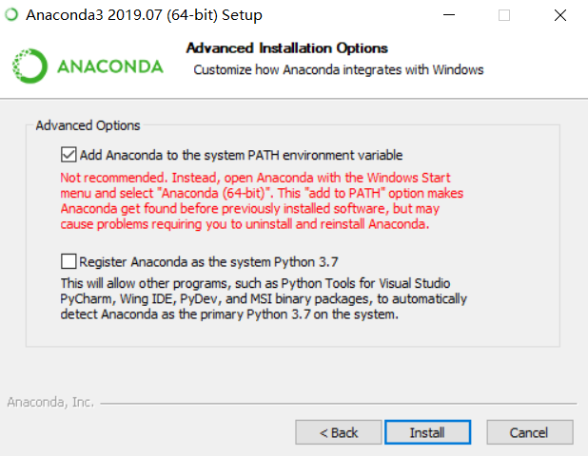
PyCharm
- PyCharm Community Edition is used as an integrated development environment (IDE) for development and debugging. Download the latest version of PyCharm from https://www.jetbrains.com/pycharm/download/#section=windows. The free Community Edition is recommended.
- Install PyCharm (Please check the box of “Add launchers dir to the PATH”)
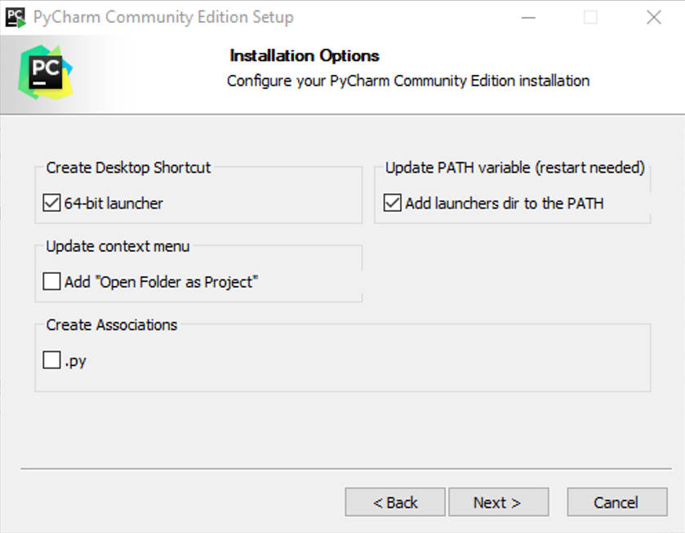

Configure PyCharm with Anaconda
- Launch JetBrains PyCharm and click “File -> Open” to Open py_FSDAF project (i.e. select the folder “py_FSDAF” and then click “OK”)
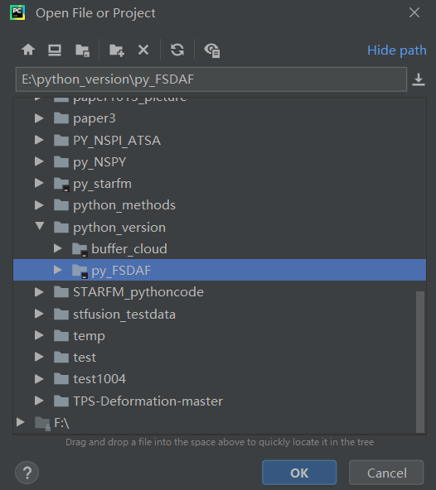
- Select File -> Settings -> Project -> Project Interpreter
- Click a settings button  for adding the python.exe interpreter that you just installed in Conda Environment to the “Existing environment”. In my case, the path is “D:\Anaconda\python.exe”, then click “OK”.
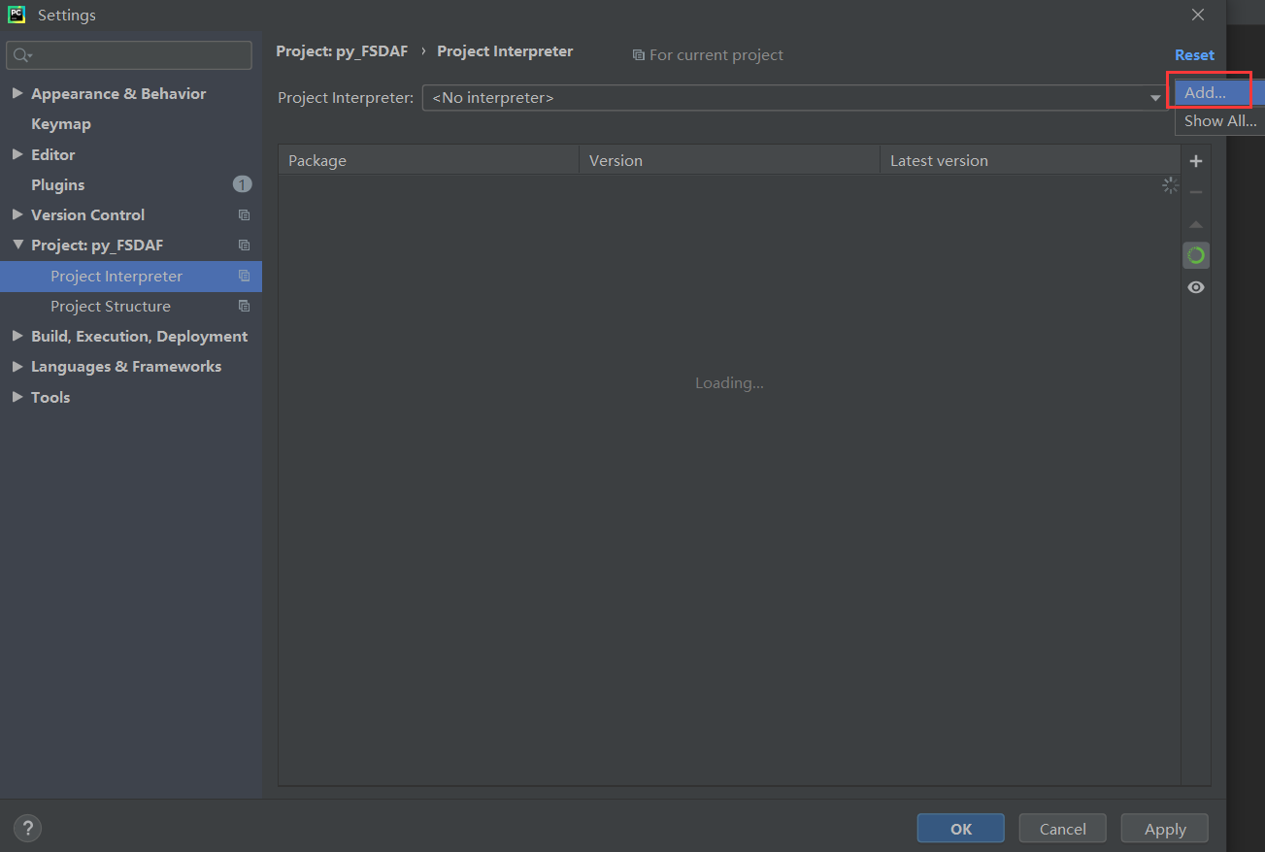

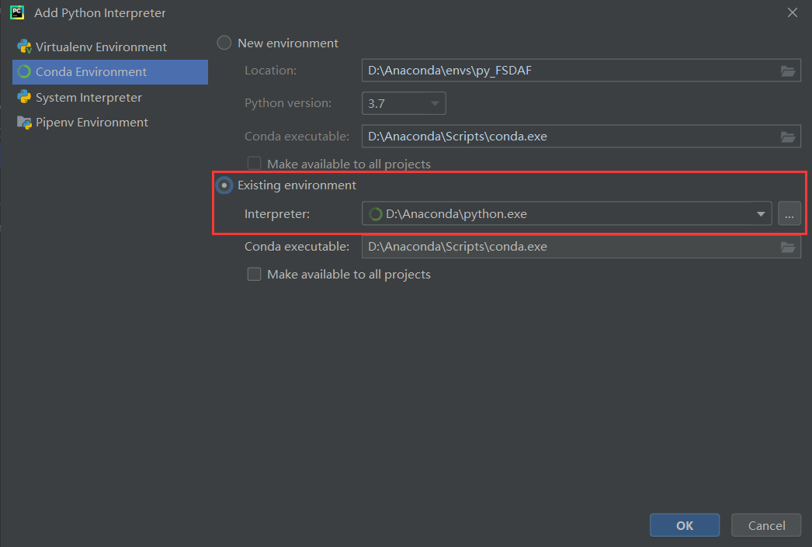

Then click “OK” in the following interface window:
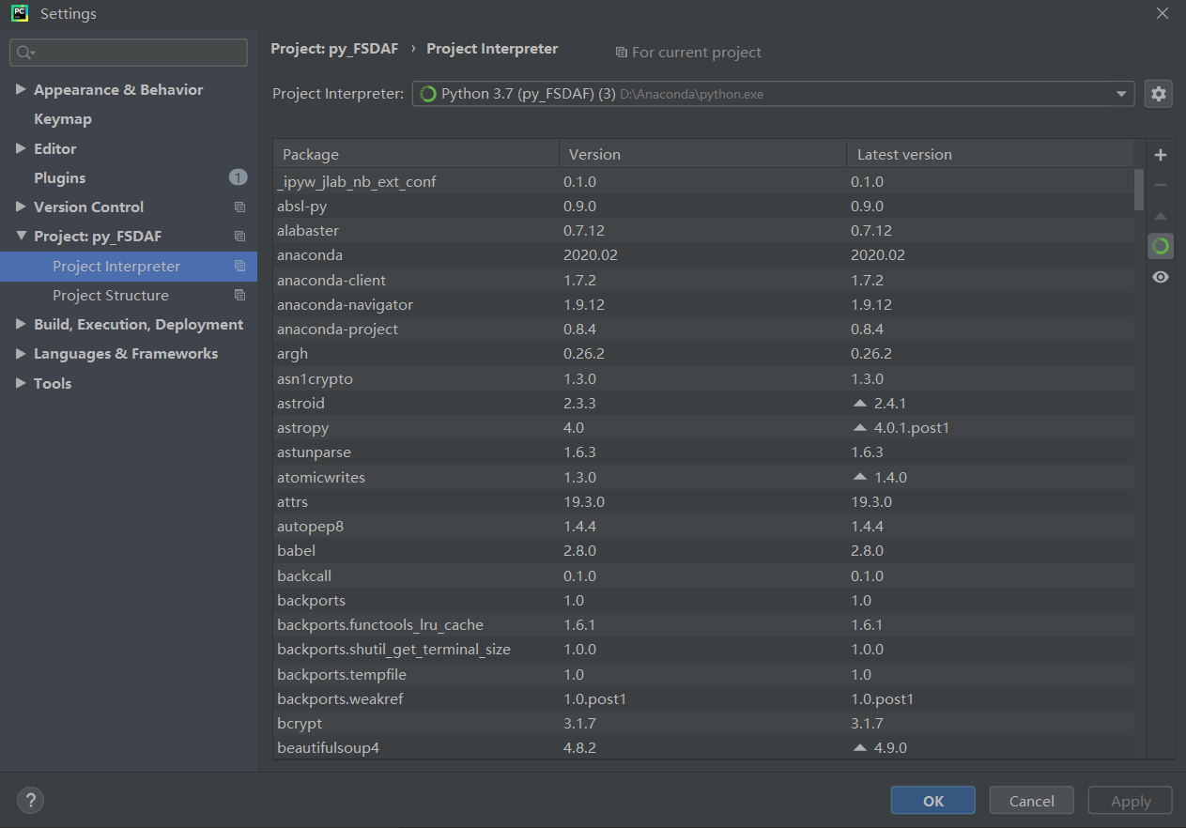

Install the required packages
- Open Anaconda Prompt in the window starter
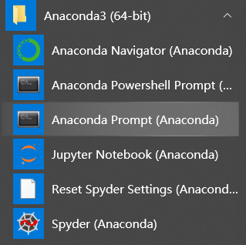
- Locate your Python Scripts path (can be found within the Anaconda installation folder) and press Enter. In my case, the Python Scripts path is: D:\Anaconda\Scripts, so in the pop-out window, type “cd D:\Anaconda\Scripts” and the press “enter”
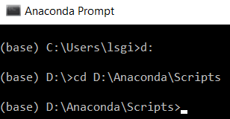
- Type “conda install gdal” and press “enter” to install the required Python package gdal (other required packages include os, numpy, yaml, statsmodels, scipy, tkinter idlwrap, many of which have been included in Anaconda, if not, please use pip install packagename to install required packages). Type “y” and press “enter” when the window shows the following message:
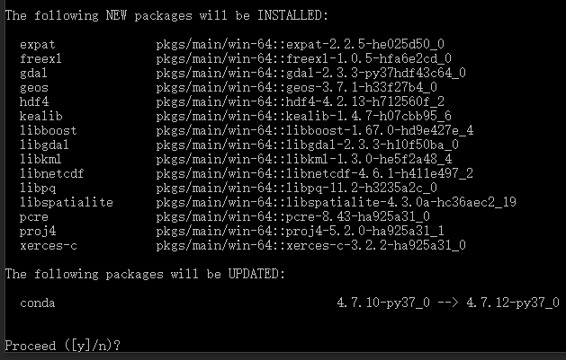

- It is done when you see the following text (if no errors appear, then the package was successfully installed)
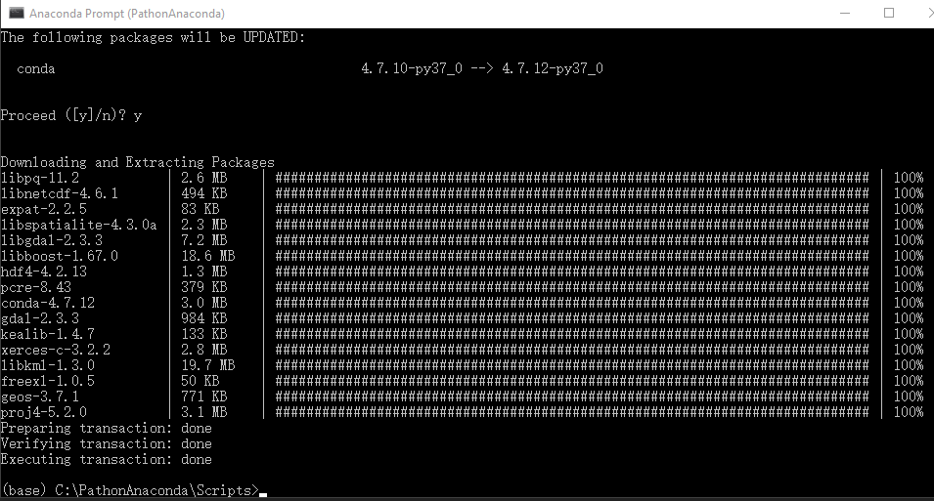

Step 2 Data Prepocessing
- In ENVI or MODS tool: resample all MODIS images to 480 m (250 m data to 240 m) use nearest neighbor method and reproject MODIS to Landsat’s projection;
- Resample Landsat image to the same resolution of MODIS (480 m or 240m) using pixel aggregate method

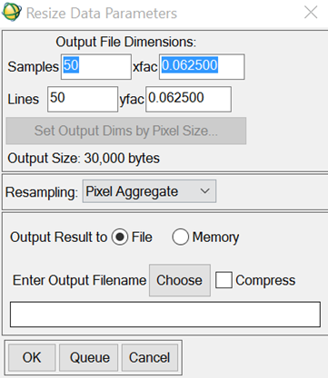

Step 3
- Geo-rectified one MODIS image to the resampled Landsat: Choose resampled Landsat as reference, correct MODIS.
- Envi/map-registration/ select GCPs: image to image
The rule derived from GCPs applied to all MODIS images
Step 4
- Crop all MODIS images by sampled Landsat, make sure they are with exactly same size:
- Envi/File/save file as envi standard/import file-select MODIS image/spatial subset/file-select Landsat/ok
- Resample MODIS to 30m by nearest neighbor method
Note: For the test data, we have done step2-step4!
- Make sure all the input data with same size and all MODIS pixels are complete pixels (have 16*16 Landsat pixels inside)

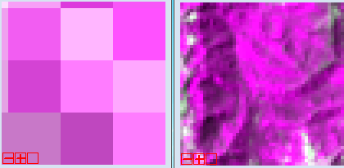
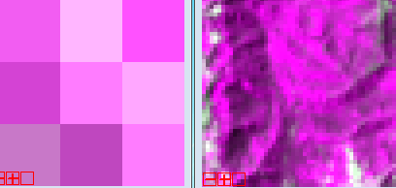

Step 5: Set parameters and pat
BAD!
GOOD

Step 5 Set the parameters
- Please follow the explanation or the paper to set the parameters, which can be set in parameters_fsdaf.yaml (and parameters_fsdaf_preclassification.yaml). The default parameters are used for test data, you can change these parameters according to your own data before using this parameter file.
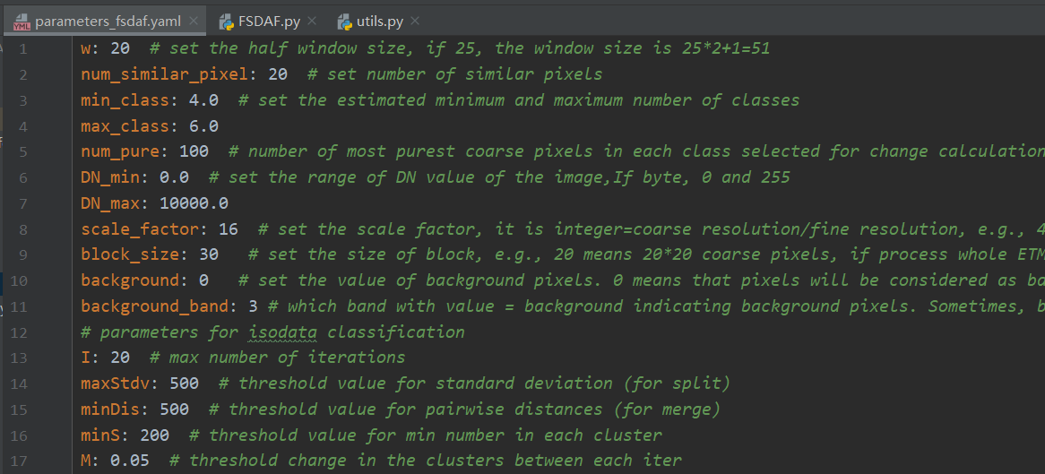
NOTE: if the input data is with only one band, please set the parameter background_band to 1.
- Since the ISODATA function used here is not the same as that in ENVI, as for the parameters for ISODATA classification, if you cannot acquire appropriate classification results, please:
- Adjust the input classification parameters into a proper range (for example, you can decrease or increase the value of maxStdx and minDis)
- Or classify input image using ENVI or other ways to get preclassification results and using FSDAF_preclassification.py to do spatio-temporal fusion work

Step 6: Run
Note:
- FSDAF: use isodata to do classification automatically. There is no need to input a classification map
- FSDAF_preclassification: users need to input a classification map from the Landsat image (for the test data, “Landsat20041126_SVM_classification” is the classification map)

Click Run -> Run ‘FSDAF’
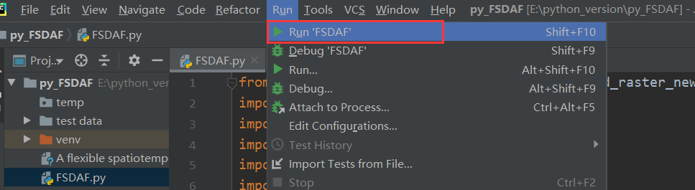
Open files according to the name of pop-up windows
- Open the parameter settings file (parameters_fsdaf.yaml or parameters_fsdaf_preclassification.yaml if using FSDAF_Preclassification)
- Set the temporary folder
- open the fine image of the first pair
- open the coarse image of the first pair
- open the coarse image of the prediction time
- open the class image of fine image in the 1st pair (if using FSDAF_Preclassification)

Output: a fused image of the original MODIS file name with a suffix “_FSDAF”

Thanks for using FSDAF algorithm. If you meet any problems, please feel free to contact Miss Yue Sun or Dr. Xiaolin Zhu.

